Task 6: Build a Simple AI-Powered Inventory Automation System (use any AI Tools)
Use your mind to select the fields and infrastructure considering various scenarios of FinOps OR EOS / EOL etc…
Eg.

integrating an API-based structure. It can enable real-time monitoring (health checks)

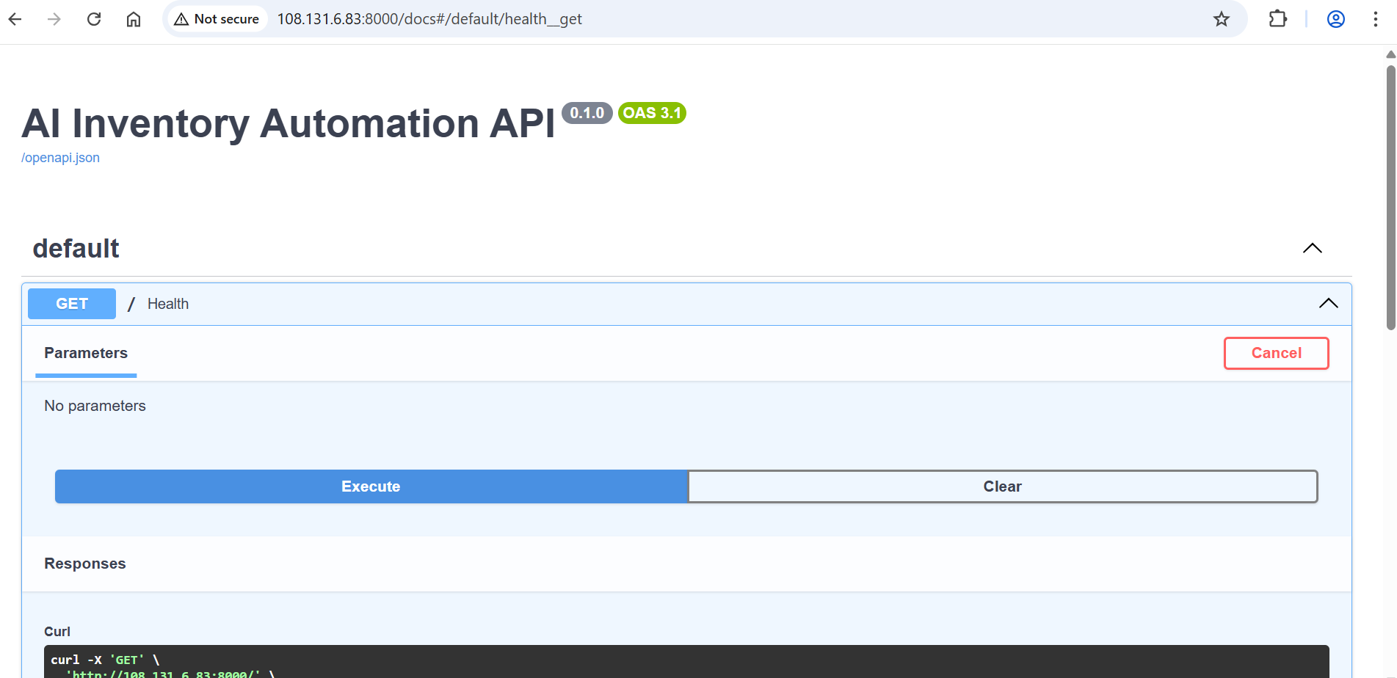

Check health
